1. Go to github >> <https://github.com/fishyimm/atmDemo> and download as zip or git clone <https://github.com/fishyimm/atmDemo.git>
2. Upzip project to your location as desired. You should see something like this.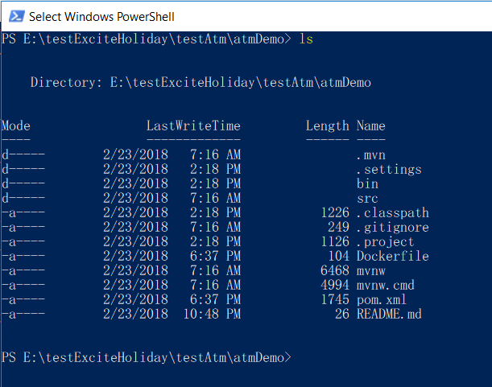
3. Run **mvn clean**   
   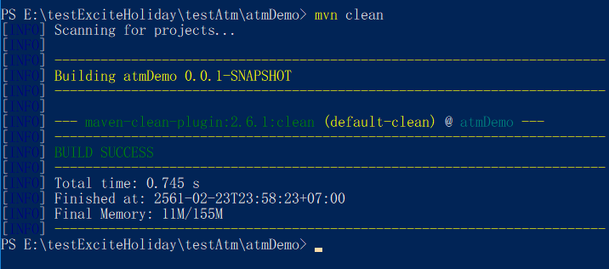
4. Run **mvn install** and wait for a while.  
   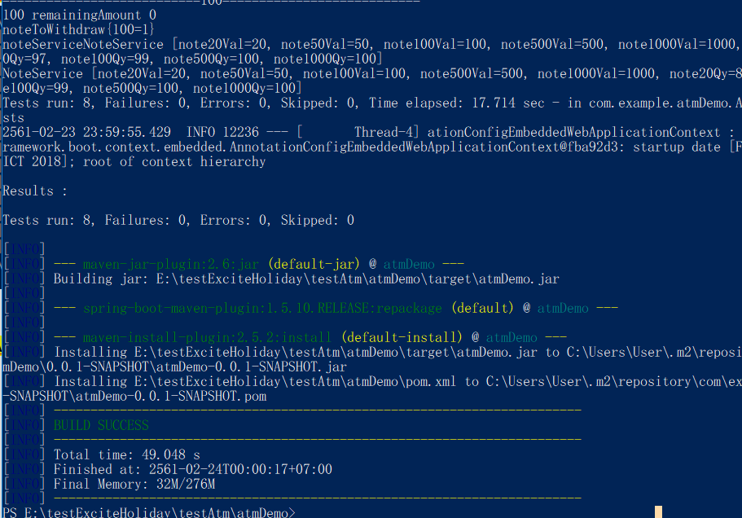
5. Now you need to create docker image using docker command >> **docker build -f <Dockerfile> -t <docker image name> "."**   
     
   -f <Dockerfile>: reference to location of Dockerfile which you create on step 5  
   -t <docker image name>: this is name of your docker image  
   **\*\*\*\*at the end of command don’t forget “.”**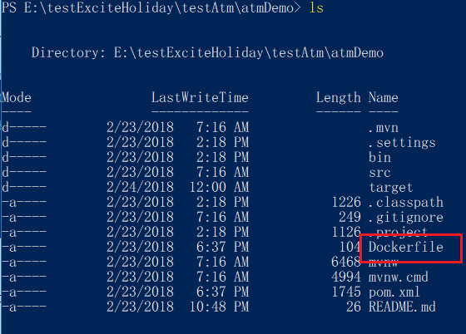  
   Complete command >> **docker build -f Dockerfile -t atmdemo .**  
   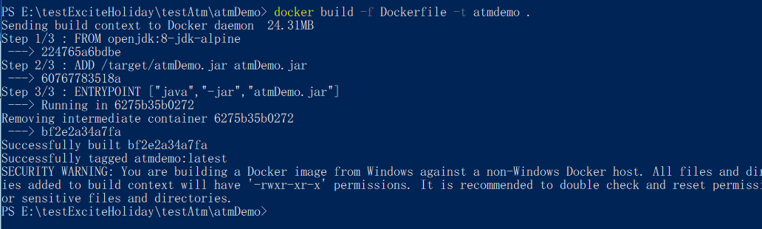
6. Now try **docker images** to check docker images  
   
7. Time to run docker imagesdocker command >> **docker run –d –p 8080:8080 atmdemo**  
     
   **docker ps** to check process  
   if you didn’t give a name container from docker run command, it will generate it for you  
   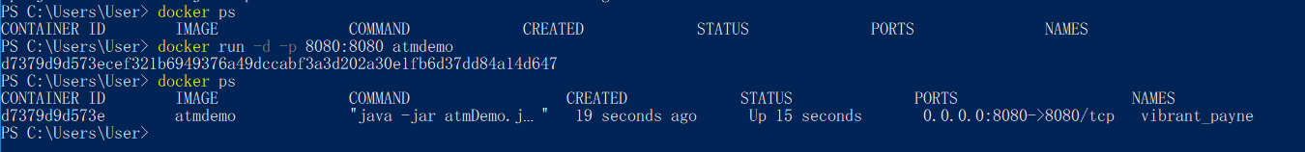
8. Now try **http://localhost:8080/** and see the result.  
   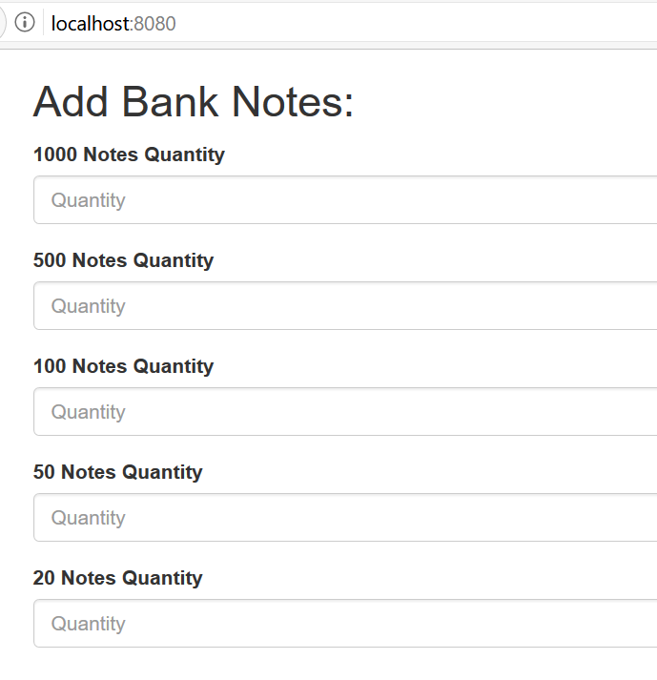  
   you need to fill all the notes to enable button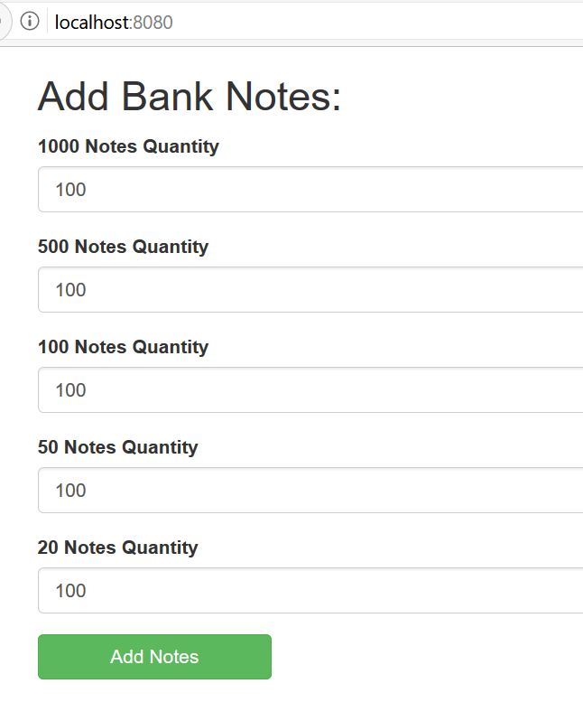
9. Enter amount, confirm and see the result.  
   